Most Productive teams and his Key Player in 2020 in top 5 League Europe

The 2020-2021 season has ended in each league. the season is running competitively. A lot of great and interesting things happened in that season. But I'm curious, can we see who is the most productive team at the end of the season by looking at their performances at the beginning of the season? this time i will try to see this point of view with the dataset i found from kaggle. This dataset contains teams from the top leagues in the world. I will see it in the top 5 European leagues which we know are the best leagues in the world. This dataset in 2020 was created when the leagues were still running around 9-11 gameweek

Before we get into the teams in the top 5 leagues, im trying to find out which league most productive in top 5 league at 2020. I decided which most productive league by goals conversion,

1. Goals Conversion Ratio

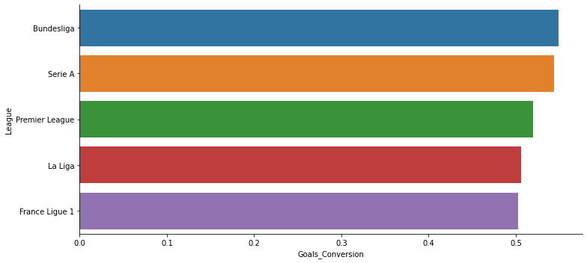

Bundesliga is the league with highest Goals Conversion, Bundesliga has 54% Possibility to Score in Every Shot Target Occur.

1. Goals Match Per Ratio

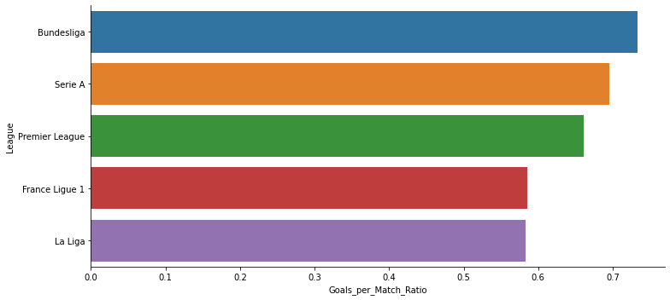

Bundesliga is the league with the highest goal per match ratio with 73% ratio. means in every match played in bundesliga, Possibility goals to occur is 73%.

1. Minutes Per Goals Ratio

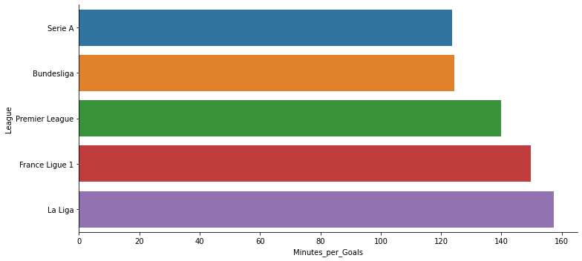

Serie A has a shortest minutes per goals ratio. Means Serie A is the league with longesttime to score a goals. Meanwhile La Liga is league with longest  minutes per goals ratiomeans. La liga is the longest time to score a goal

1. Diff Goals-XG

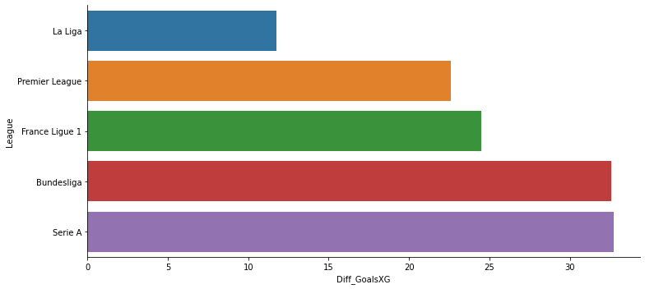

Serie A has the highest value of Diff Goals and XG. Means Serie A competition is much more productive than expected.

Overall , Bundesliga is the most productive league. Bundesliga has a highest Goals Conversion, Goals per Match ratio, and second highest minutes per goals ratio than 4 leagues other.

Lets see the facts in each league.

1. Bundesliga

* Most Productive Player in the league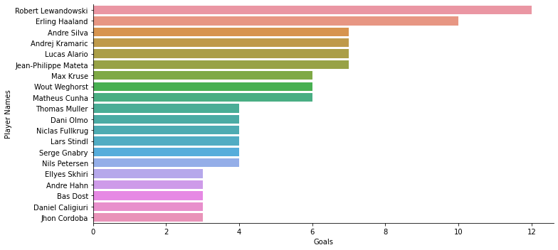

Robert Lewandowski, is the top scorer so far with 12 goals and 1,7 goals match . It makes him the most lethal scorer per Gameweek 9.

* Most Productive Club in the league

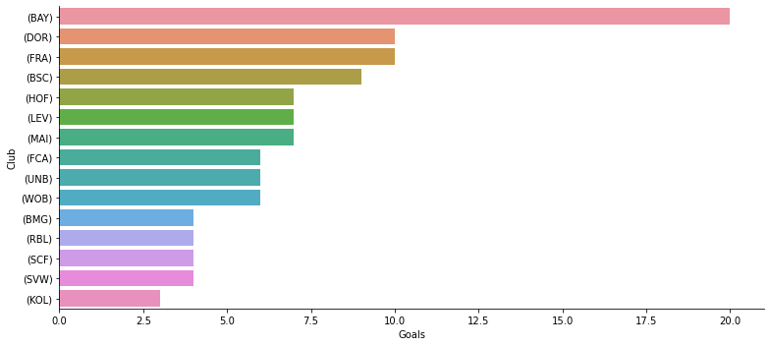

Bayern Munchen is the most productive teams with 20 goals scored in 23 matches they players played.

* Key player of the most productive in bundesliga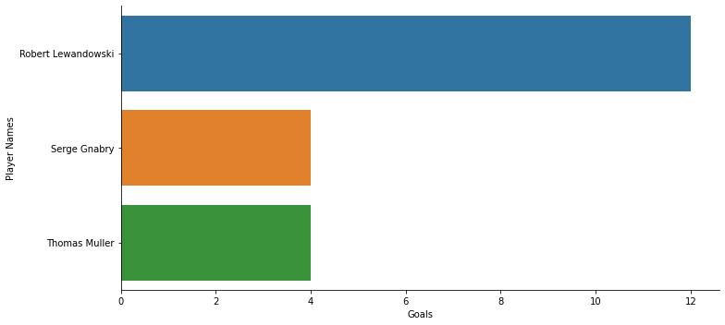

Robert Lewandowski is Key Player to makes Bayern Muenchen being the most productive teams in the league with his contribution to Score 12 Goals in 7 matches his played.

* Result in the end of season

Bayern Muenchen is the Champion of Bundesliga 2020-2021 with 99 Goals scored. Robert Lewandowski Contributing 41 Goals in the end of season.

1. Serie A

* Most Productive Player in Serie A

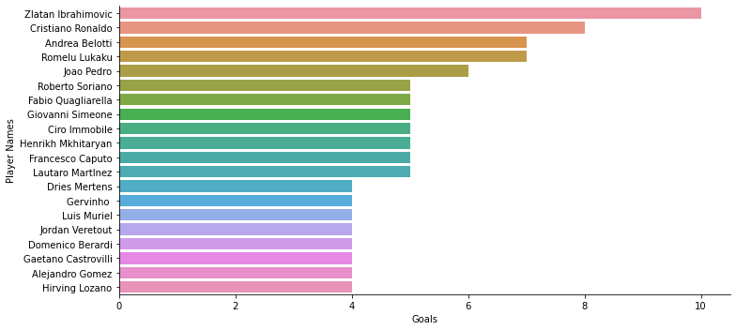Per Gameweek 9 , Zlatan Ibrahimovic is the produtive player in the league with 10 Goals in 6 Games he played

* Most Productive Team Serie A

Inter Milan is the most productive teams with 12 goals scored from 13 matches they players played.

* Key Player in the most productive team in the league.

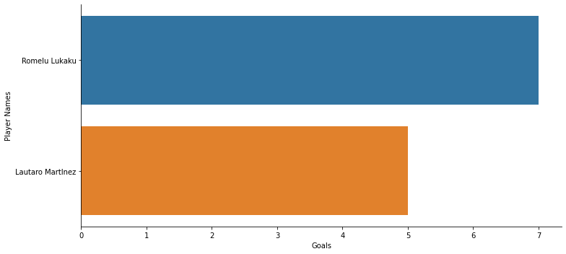

Romelu Lukaku is the Key Player for Inter Milan. With his contribution with 7 Goals in 6 Games he played makes Inter Milan The Most Productive teams until gameweek 9 in league 2019-2020.

* Result in the end of season

In the end of season , Inter Milan is the Champion of Serie A 2019-2020. With 89 goals scored. Lukaku contributing 24 Goals in that Goals and being 2nd Top Scorer in that season.

1. Premier League

* Most Productive Player

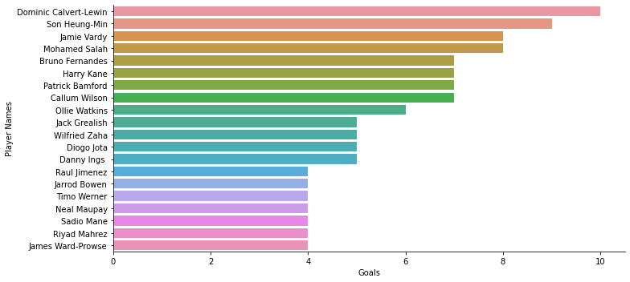

Dominic Calvert Lewin is the most productive player to score so far in English Premier League with 10 Goals in 10 match his played.

* Most Productive Teams

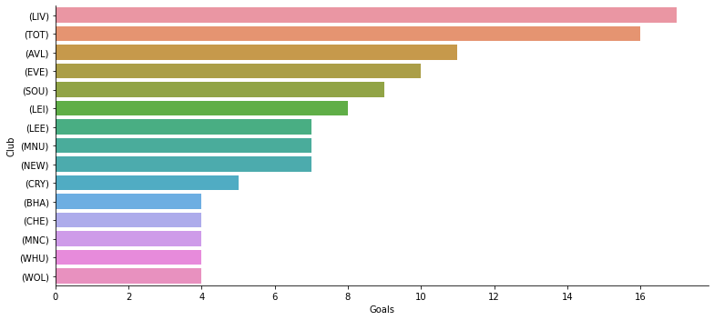

Liverpool is the most productive team with 17 goals in 22 matches they players played.

* Key Player in the most productive team in Premier League

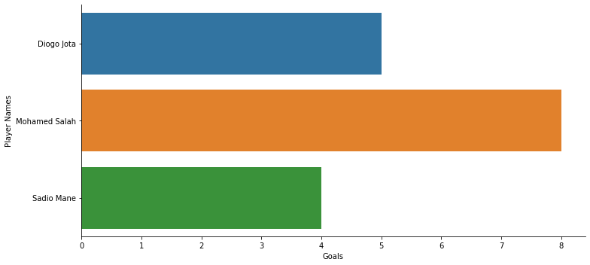

Mohamded Salah is the most productive player in the liverpool. With his contribution, 8 Goals in 9 Matches makes him as a key player to make Liverpool most productive team in the league until Gameweek 9.

* Result in the end of season

In the end of season, Manchester City win the Premier League and being a Most Productive team with 83 goals scored. Hary Kane is the scorer with 23 goals scored. Mohamed Salah being 2nd top scorer with 22 goals scored throughout the season.

1. La Liga

* Most Productive Player

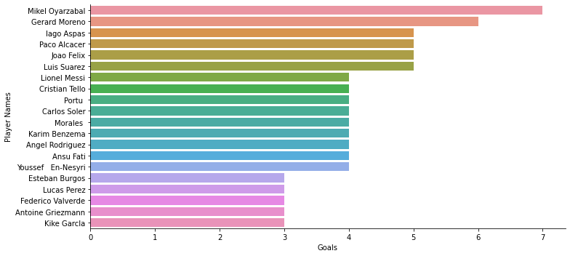

Mikel Oyarzabal is the most productive player in the league with his 7 goals in 9 mathches his played with Real Sociedad

* Most Productive Club in La Liga



Barcelona and Sociedad is the most productive teams in the league with 11 goals. But Sociedad is more effective because Sociedad can score 11 goals from 15 matches they players played.

* Key Player in The Most Productive La Liga

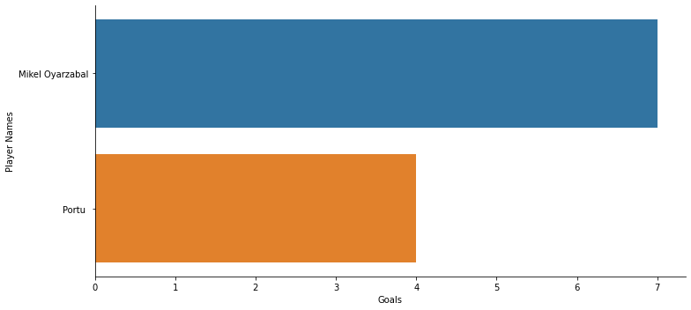

Mikel Oyarzabal is the key player in Real Sociedad with his 7 goals in 9 mathes his played with Real Sociedad.

* Result in the end season

In the end of season, Atletico Madrid Winning the league. Barcelona take a third placem but being the most productive teams with 85 goals scored throughout the season. Lionel Messi with his 30 goals makes barcelona most productive goals and contributing to make barcelona most productive team in the league.

1. Ligue 1

* Most Productive Player in Ligue 1

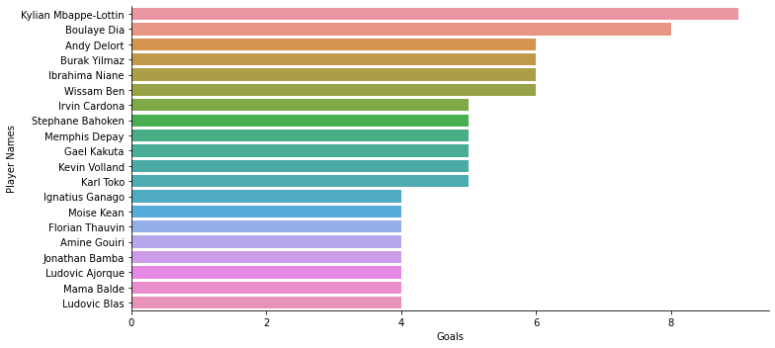

Kylian Mbappe is the Most Productive player in the league with his 9 goals in 7 matches his played with PSG

* Most Productive team in Ligue 1

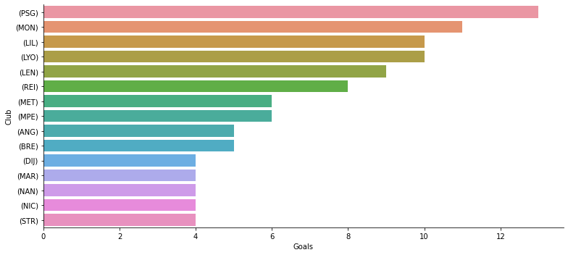

PSG is the most productive team in the league with 13 goals in 13 matches they played.

* Key Player in the Most Productive team in the Ligue 1

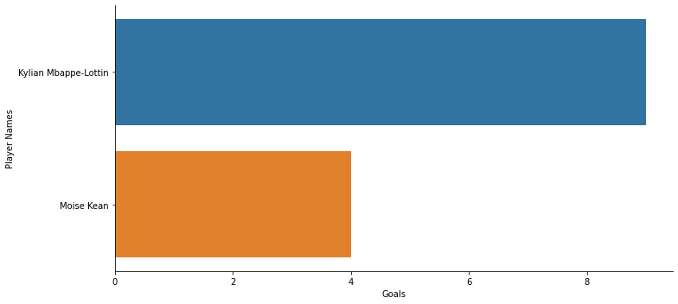

Kylian Mbappe is the most productive player in the league with his 9 goals in 7 matches his played. His contribution makes PSG is the most productive team in the league.

* Result In The End Season

In the end of season, Lille winning the league 64 goals scored and gained 83 points. PSG takes the second place in that season and being the most productive teams in the league with 86 goals scored. Kylian Mbappe being top scorer with 27 goals . Its makes PSG being the most productive teams in the league.

Overall , performance in gameweek 9-11 in 2020 representing the result in the end of season. But in some league like premier league, La Liga it doesn’t represent result in the end of season.